**ASSIGNMENT 10**

NAME : Bhavik Ransubhe

CLASS : TE( B ) COMP

ROLL NO : 39055

--------------------------------------------------------------------------------------------------------------------------------------

**CREATE DATABASE AND COLLECTION :**

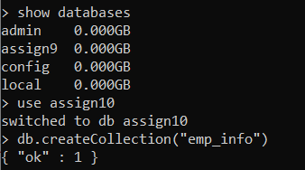

**INSERTING VALUES IN COLLECTION :**

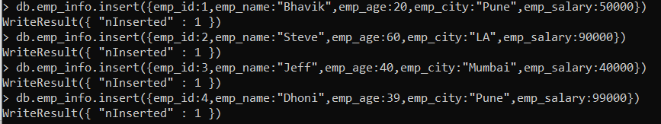

**DISPLAYING VALUES IN COLLECTION USING PRETTY :**

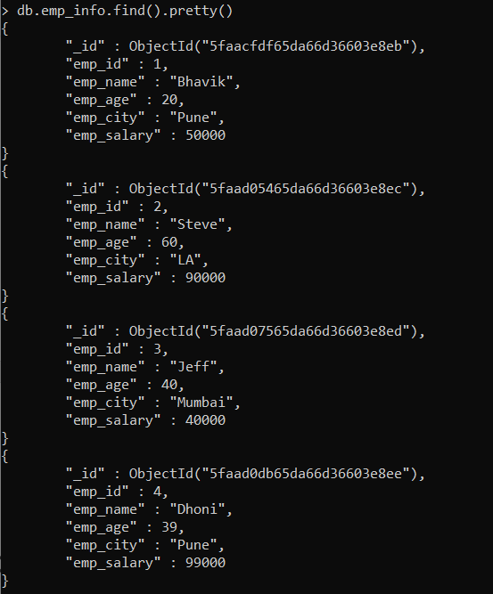

**Displaying employee info sorted on name field :**

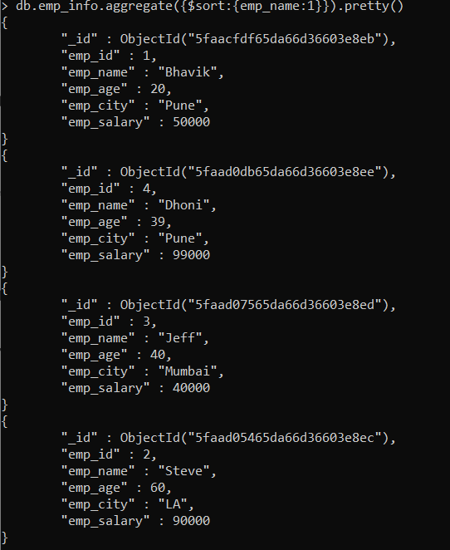

**Display employees whose name start with “B”:**

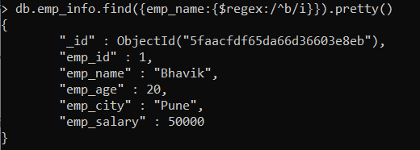

**UPDATING VALUES IN THE COLLECTION :**

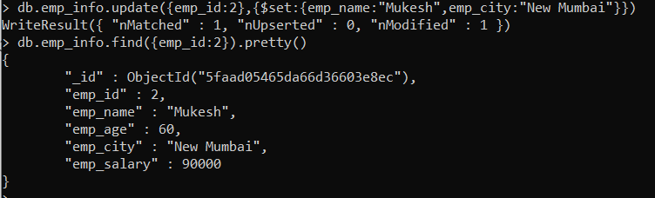

**SAVE method :**

* **Save a New Document Specifying an _id Field (To avoid ObjectId) :**

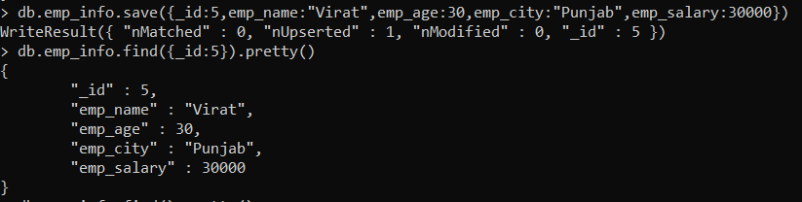

* **Replace an Existing Document**

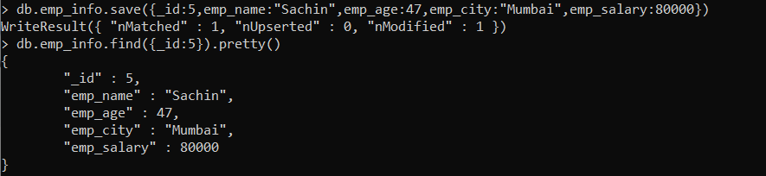

**LOGICAL OPERATORS :**

1. **$and:**

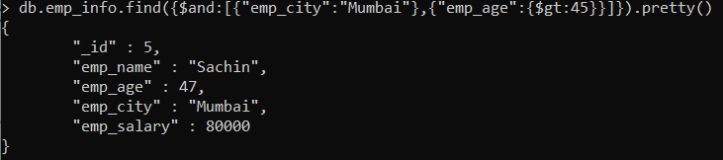

1. **$not:**

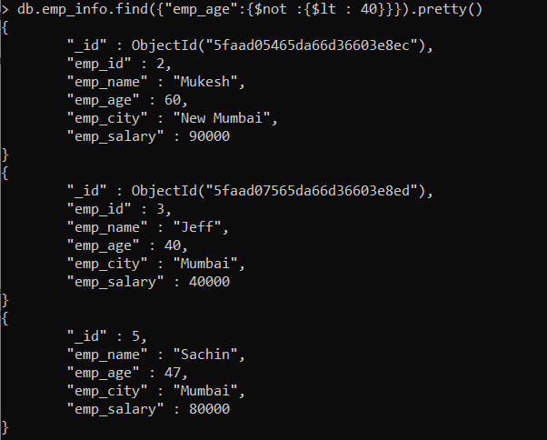

1. **$or :**

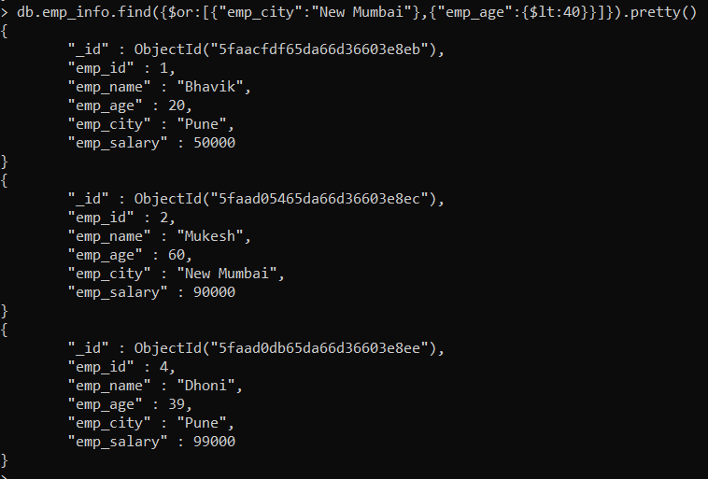

1. **$nor :**

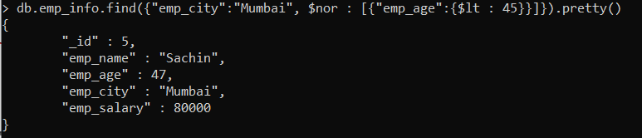

**DISPLAY TOTAL NO OF DOCUMENTS :**



**REMOVING A VALUE FROM THE COLLECTION :**



